Digital Democracies

Artist Call Out
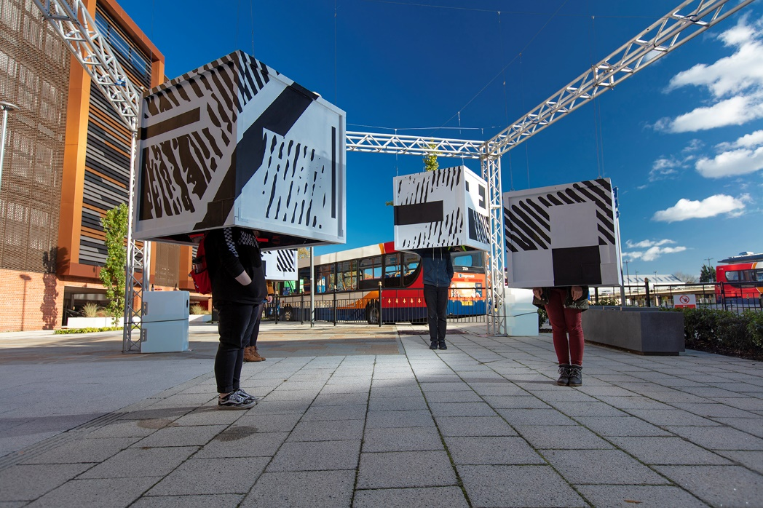

Brief Overview
Digital Democracies are seeking proposals for new immersive or location-based audio work* designed to be experienced in public and outdoor spaces.

Digital Democracies is a national partnership project exploring technology-enabled art in public spaces. The partnership aims to foster a new generation of radically inclusive public cultural experiences. Digital Democracies is Threshold Studios (producer of Frequency Festival of Digital Culture), Freedom Festival Arts Trust and Brighton Digital Festival managed by Lighthouse Brighton.

We would like to invite ideas that are:

- Responsive to the core idea of Connections - between people, places, countries, past/future
- Iterative - prototyped with an audience in March 2021 (in either Brighton or Hull and/ or virtually) and then developed for another showing in May as part of the Brighton Festival programme.
- Place-responsive - with elements of local engagement with people, archives, heritage or landscapes (In either one - or more - of Brighton, Lincoln and Hull).
- Able to tour - through Digital Democracies, there is an option for additional showings in Hull (August) and Lincoln (October) which will be separately financed.
- Covid-safe - Able to be developed and presented within Covid-secure guidelines, making allowances for possible on-going social distancing in March and May.
- Inclusive - Relevant to our audiences and with accessibility considered, in order to be as inclusive as possible.
- In-keeping with the values of Digital Democracies, Re:Imagine Europe and Brandwatch (see Further Information).

We welcome ideas for both full projects and prototypes, although the project must be able to be tested with audiences.

The budget for the project is £6000 (inc VAT) to include all fees, equipment and materials and the presentation costs for the two showings in March and May 2021.

This commission opportunity has been made possible through co-funding from Reimagine Europe and Brandwatch.

*Immersive audio is 3D audio with sounds coming from different directions and heights, most often used in VR, AR, XR and gaming. Location-based audio is audio content triggered by listeners location and movement.

How to apply
Send applications to: digitaldemocracies@thresholdstudios.tv
Deadline: 5pm, Friday 8th January 2021

Applications should include:

- Creative Proposal highlighting the creative idea and addressing the requirements in the brief (max 3000 characters/ one A4 page)
- Examples of previous work and/or CV or portfolio (max 10MB)
- Outline budget showing initial estimates of artistic and technical fees, materials, estimated hires and purchases and other costs (transport, insurance etc)
- Contact Information (name, email, phone, website and home address)
- An image to support idea or experience (max 5MB) - Optional

If you have any access requirements and would like this information in an alternative format or would like to discuss alternative means of applying (for example by video) then please make contact with us at digitaldemocracies@thresholdstudios.tv

What happens next?
Applicants will be notified of a decision in w/c 18th January 2021.

We are intending to select one proposal, but will work with unsuccessful applicants to identify additional support and training that we can provide. There will also be other opportunities in the future.

Assessment Criteria
Applications will be assessed by the Digital Democracies leadership team according to the following criteria:

- Originality and ambition of the creative idea (25)
- Experience, track-record and skills of the project team (20)
- How well the project meets the brief (15)
- The application of new and emerging technologies (15)
- Accessibility and relevance to our audiences (15)
- Viability/ Value for money - from budget info (10)

Timescale
Dates | Activity
Wednesday 25th November | Open Call published
Friday 4th December at 11am | Online briefing by Zoom – booking via Eventbrite here
Friday 8th January at 5pm | Deadline for applications
Thursday 14th January | Panel meets
W/C 18th January | Applicants notified
March 2021 (dates tba) | Prototype show
May 2021 (dates tba) | Premiere show
August onwards | Available for touring

Digital Democracies Partners
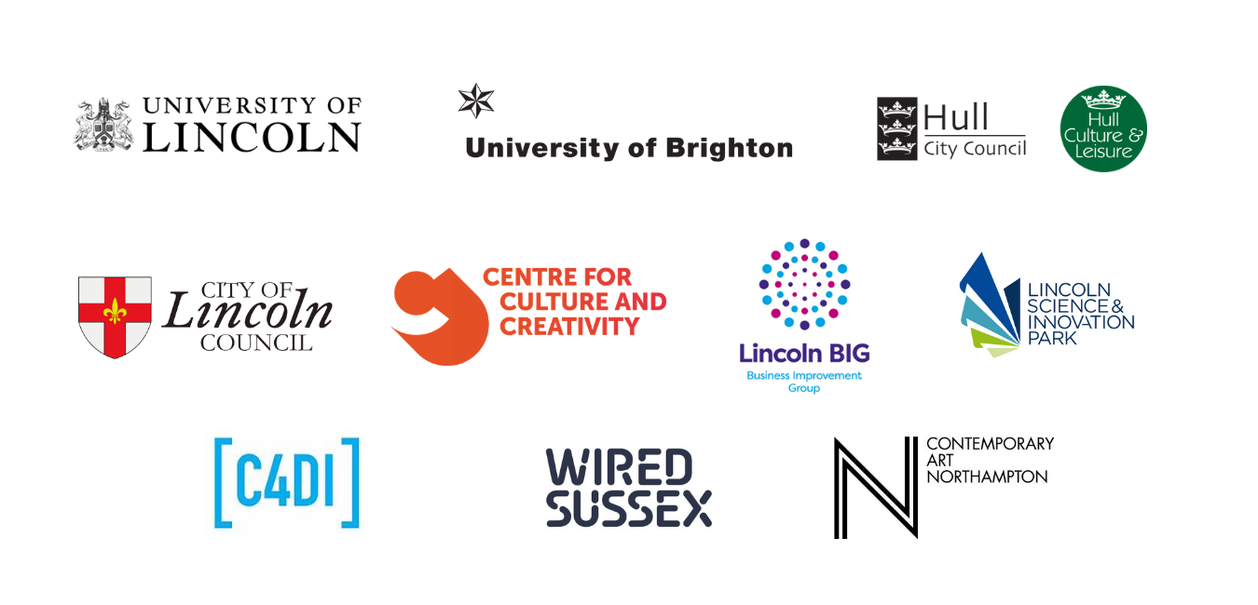

Further Information about Digital Democracies

Digital Democracies
Digital Democracies is a national project is led by Threshold Studios, an organisation with a longstanding reputation in cultural equality and innovation through digital creativity. It is supported using public funding by Arts Council England.

Digital Democracies connects three UK-based festivals, Frequency International Festival of Digital Culture in Lincoln (Produced by Threshold Studios), Freedom Festival in Hull (Produced by Freedom Festival Arts Trust) and Brighton Digital Festival (produced by Lighthouse and Brandwatch), along with a network of associate partners and collaborators across the UK.

Supported using public funding by Arts Council England and by Threshold Studios, Freedom
Festival Arts Trust and Brighton Digital Festival through their partners and funders.

Vision: Cultural equality and innovation through digital creativity: people powered place
shaping.

Mission: To animate and transform public spaces through democratic digital creativity and innovation, developing new audiences, opportunities and the way we view the places we live, work and inhabit.

Values:
Core Values | Key Messages
1. High Quality | We produce high-quality commissions to exhibit in public spaces
2. Nurturing | We embed artist and skills development into R&D prototyping and commissioning. We use combined experience to strengthen and invigorate the cultural sector and increase potential for risk and experimentation.
3. Democratic / Inclusive | We ensure democratic access to artists and audiences to maintain inclusivity. Democracy is at the heart of the project, we commission and develop from the perspective of inclusion.
4. Innovative | We provide a space for beta testing of new ideas and new works to enhance innovation within the UK creative and cultural sector.
5. Connecting | We connect artists, technologists, communities and audiences to share knowledge.

Re-Imagine Europe
This commission will be part of Re-Imagine Europe, which is co-funded by the Creative Europe programme of the European Union. Re-Imagine Europe is initiated by Sonic Acts (NL) and coordinated by Paradiso (NL) in collaboration with Elevate Festival (AT), Lighthouse (UK), Ina GRM (FR), Landmark / Bergen Kunsthall (NO), A4 (SK), Disruption Network Lab (DE), Ràdio Web MACBA (ES), Urban Paradoxes (NL) and Kontejner (HR).

Rising nationalism, climate change and migration are drawing European countries apart, while technological advances continue to change the ways that we interact, urging us to explore new modes of operation.

Re-Imagine Europe is a four-year project with 10 cultural institutions from across Europe, addressing the social and political challenges we face today. Re-Imagine Europe is co-funded by the Creative Europe programme of the European Union. Lighthouse in Brighton is the UK partner

Brandwatch
Brandwatch is the world’s leading social intelligence company, with world-leading people at the heart of it. They build intelligent software solutions that meet the needs of over 1,200 forward-thinking businesses, including Unilever, Whirlpool, British Airways, Walmart and Dell. Recently named a Leader in the Forrester Wave report into the global social listening sector, Brandwatch scored highest in strong vision and values and incorporating and understanding non-social voices, sentiment and emotion.

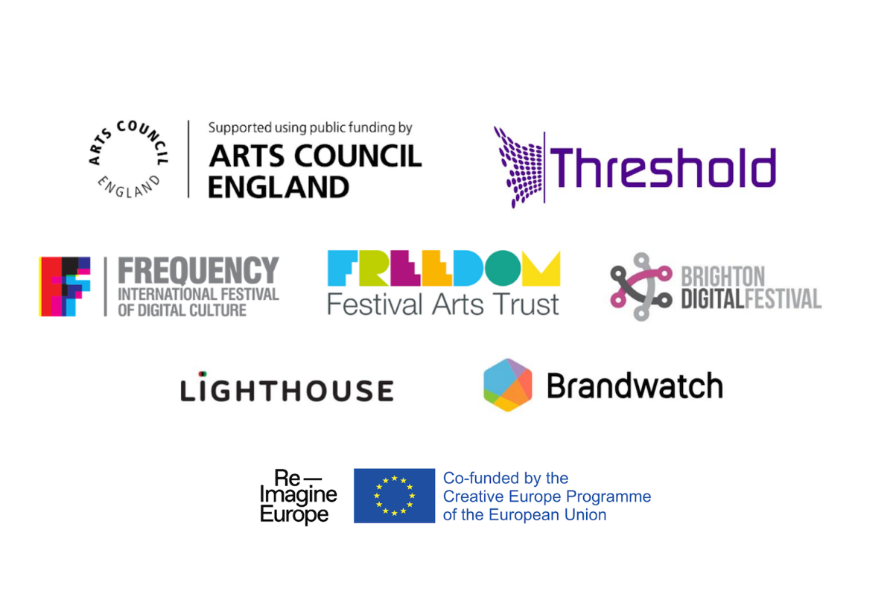
Born in Brighton and with its HQ still in the city, Brandwatch is one of Brighton's ‘fused’ creative/ digital success stories. They are a founding partner of Brighton Digital Festival, supporting artist commission opportunities each year with a focus on innovation and emerging artists.

