WE-Hope & Digital Democracies

Call-Out for Artist Proposals

Deadline for applications: 5th July

WE-Hope and Digital Democracies are seeking proposals for an artist to update the ancient visual storytelling notion of the Cantastoria using digital augmentation, as part of this international arts project and initiative.

“Cantastoria (pronounced [ˌkantaˈstɔːrja]; also spelled cantastorie [ˌkantaˈstɔːrje], canta storia or canta historia) comes from Italian for "story-singer" and is known by many other names around the world. It is a theatrical form where a performer tells or sings a story while gesturing to a series of images. These images can be painted, printed or drawn on any sort of material.”

The commissioned artist(s) will work with living testimony from survivors of conflict to create an interactive digital animation that can be shown in public outdoor space.

Ideally, the piece will be generative and able to be influenced by audiences experiencing the work either online or in public space.

The final animation will be presented alongside a live choral performance of a new composition inspired by the testimony commissioned for the project.

We invite ideas that:

- Respond to the themes and impetus of the overall WE-Hope project and Digital Democracies (See Further Information section)
- Can be presented both physically (for example on a screen or as an installation) and digitally (either as an animation, film, or social interaction) through online platforms.
- Interactive: Has the scope to be influenced by input from public audiences responding to the work.
- Able to tour: Through Digital Democracies there is an option for simultaneous showings in Lincoln and Brighton as well as future presentations through WE-Hope’s international network.
- Able to be developed and presented within covid-secure guidelines making allowances for possible on-going social distancing in October
- Relevant to our audiences and considering diversity and accessibility in order to be as inclusive as possible
- In keeping with the values of Digital Democracies, Creative Europe and WE-Hope (see further information)

We welcome ideas for both full projects and prototypes, although the project must be able to be tested with audiences.

The budget for the project is 8000 Euros (inc VAT) to include all fees, equipment and materials. Additional budget can be made available to support the showing of work in two locations. It is anticipated that the majority of the work will be completed online but travel will be negotiated outside of this budget.

How to apply:

Applications should be emailed to: digitaldemocracies@thresholdstudios.tv and be received by 5pm on 5th July.

Applications should include:
- Creative Proposal highlighting the creative idea and addressing the requirements in the brief (max 3000 characters/ one A4 page)
- Examples of previous work and/or CV or portfolio (max 10MB)
- Outline budget showing initial estimates of artistic and technical fees, materials, estimated hires and purchases and other costs (transport, insurance etc)
- Contact Information (name, email, phone, website and home address)
- Option to include an image to support idea or experience (max 5MB)

If you have any access issues and would like this information in an alternative format or discuss alternative means of applying (for example by video) then please make contact with us at digitaldemocracies@thresholdstudios.tv

What happens next?
Applicants will be notified of a decision in July 21 (Please see timeline below)

We are intending to select one proposal but will work with unsuccessful applicants to identify additional support and training that we can provide. There will also be other opportunities in the future.

Assessment Criteria
Applications will be assessed by the Digital Democracies and WE-Hope leadership team according to the following criteria:
- Originality and ambition of the creative idea (25)
- Experience, track-record and skills of the project team (20)
- How well the project meets the brief (15)
- The application of new and emerging technologies (15)
- Accessibility and relevance to our audiences (15)
- Viability/ Value for money - from budget info (10)

Timescale:

Dates | Activity
2nd June | Open Call published
14th June | Online briefing by Zoom – booking via Eventbrite here
5th July | Deadline for applications
9th July | Panel meets
12th July | Applicants notified
Between 28th and 31st October | Premiere show

FURTHER INFORMATION

About WE-Hope:

See https://www.we-hope.eu/about for full information

WE-Hope is a partnership project that addresses the challenges of social cohesion/inclusion across Europe, and the stresses that are resulting from anxiety about ‘others’ and social fracturing, as witnessed in the Brexit vote in 2016 and the re-emergence of far-right parties.

Based on this motivation, we plan to contribute to meeting this need by building a website/repository of stories and associated objects through collecting the stories of survivors in conflicts that have occurred in Europe as well as elsewhere, resulting in people fleeing to find sanctuary in Europe via testimonial interviews, creating an artwork inspired by the stories; by creating educational resources inspired by the stories; and through all these outputs, by engaging with identified audiences who will add and reuse content.

In order to:
- Promote the transnational mobility of artists and professionals with a view to enabling them to cooperate internationally and to internationalise their careers;
- Strengthen audience development as a means of improving access to European cultural and creative works and tangible and intangible cultural heritage and extend access to cultural works to children, young people, people with disabilities and underrepresented groups;
- Enhance intercultural dialogue, promote shared EU values of tolerance, MUTUAL UNDERSTANDING and respect for other cultures, thereby contributing to the social integration of migrants and refugees into the societies in which they now live.

WE-Hope Context:

Across the continent from 1939 to 1945, civilians were subjected to what have often been called acts of barbarism: extermination on the basis of ethnicity/belief; wholesale destruction from the air; expulsion from vast areas; violation by invading troops. Coming to terms with these events continues to be a work in progress, one that has been foundational in the promotion of tolerance and peace in the twenty-first century. Significantly, the further into the past the Second World War recedes, the more ‘memory work’ about it there seems to be. Eyewitnesses to the war still survive, though they are now few in number. Several initiatives have already been set up to capture their memories for posterity; among these are partners Memoro, Lapsus, Greek Bank of Memories and the University of Lincoln.

In more recent years, many newcomers have been accepted into European societies, some of them having fled intractable war-torn conditions across the Middle East and North Africa. There has not been an equivalent effort to capture their stories. Their arrival has raised many challenges, not least to the ‘tolerance consensus’ that is a central value of the European Union and those in the UK who opposed Brexit. Very little connection has so far been made between the ‘memory work’ of the Second World War and the memories of those who have more recently escaped war and conflict to find a refuge in Europe.

We believe that bringing these stories into dialogue will contribute to a recognition of shared experiences that can promote a sense of common humanity and citizenship. There is also an additional intergenerational dimension, an intended dialogue (not necessarily face to face but certainly online) between elders and younger generations. The concept of re-imagining collections based on inclusivity will also underpin attempts to reach diverse audiences. Making such connections is an innovative approach to shared story-telling and creative art

WE-Hope Partners:

The partnership consists of two higher education institutions (the National Technical University of Athens (NTUA)and the University of Lincoln (UoL)), three cultural associations (Memoro, Greek Bank of Memories, Michael Culture AISBL (MCA)) and Threshold Studios.

Together these partners are located in four EU countries: Greece, Italy, Belgium and the UK.

The wider partnership includes associate partnerships with Lapsus, DI + Association and Manchester Refugee Network

Digital Democracies:

Digital Democracies is a national project exploring technology enabled art in public spaces which aims to foster a new generation of radically inclusive public cultural experiences is led by Threshold Studios, an organisation with a longstanding reputation in cultural equality and innovation through digital creativity. Digital Democracies connects three UK-based festivals, Frequency International Festival of Digital Culture in Lincoln (Produced by Threshold Studios), Freedom Festival in Hull (Produced by Freedom Festival Arts Trust) and Brighton Digital Festival (Produced by Lighthouse and Brandwatch), along with a network of associate partners and collaborators across the UK.

Supported using public funding by Arts Council England and by Threshold Studios, Freedom
Festival Arts Trust and Brighton Digital Festival through their partners and funders.

Vision: Cultural equality and innovation through digital creativity: people powered place
shaping.

Mission: To animate and transform public spaces through democratic digital creativity and innovation, developing new audiences, opportunities and the way we view the places we live, work and inhabit.

Values:

Core Values | Key Messages
1.High Quality | We produce high-quality commissions to exhibit in public spaces
2. Nurturing | We embed artist and skills development into R and D prototyping and commissioning using combined experience to strengthen and invigorate the cultural sector and increase potential for risk and experimentation.
3. Democratic /Inclusive | We ensure democratic access to artists and audiences to maintain inclusivity. Democracy is at the heart of the project, we commission and develop from the perspective of inclusion.
4. Innovative | We provide a space for beta testing of new ideas and new works to enhance innovation within the UK creative and cultural sector.
5. Connecting | We connect artists, technologists, communities and audiences to share knowledge

Project Partners and Funders:
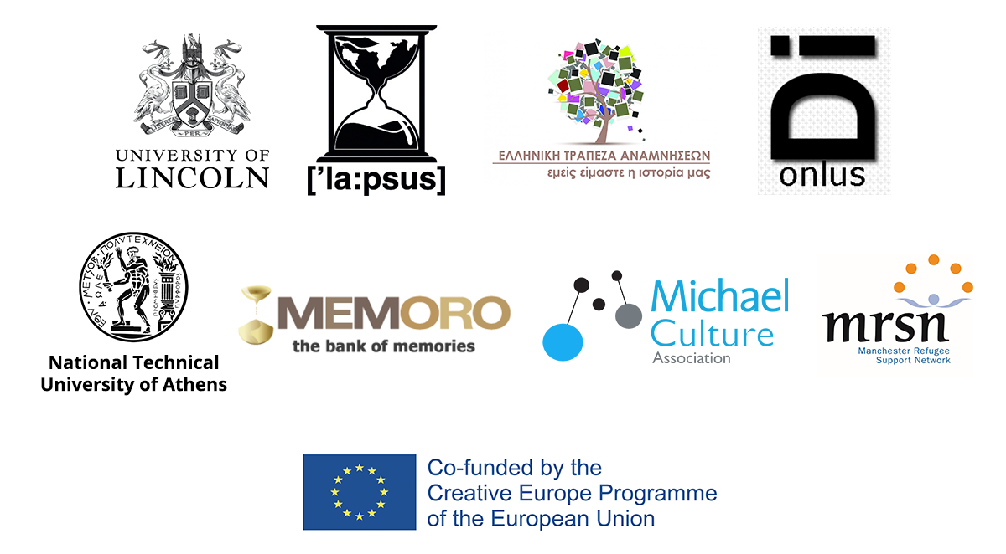

WE-Hope is Co-financed by the Creative Europe Programme of the European Union. The content of this document represents the views of the author only and is his/her sole responsibility. The European Commission does not accept any responsibility for the use that may be made of the information it contains.
